**CHAT APP DESIGNS**

These are some of the application designs that I have created on my own using android studio.

**STAGE 1**

The screen of the app is simple with the blue heading and the project name “ChatApp” written on it.

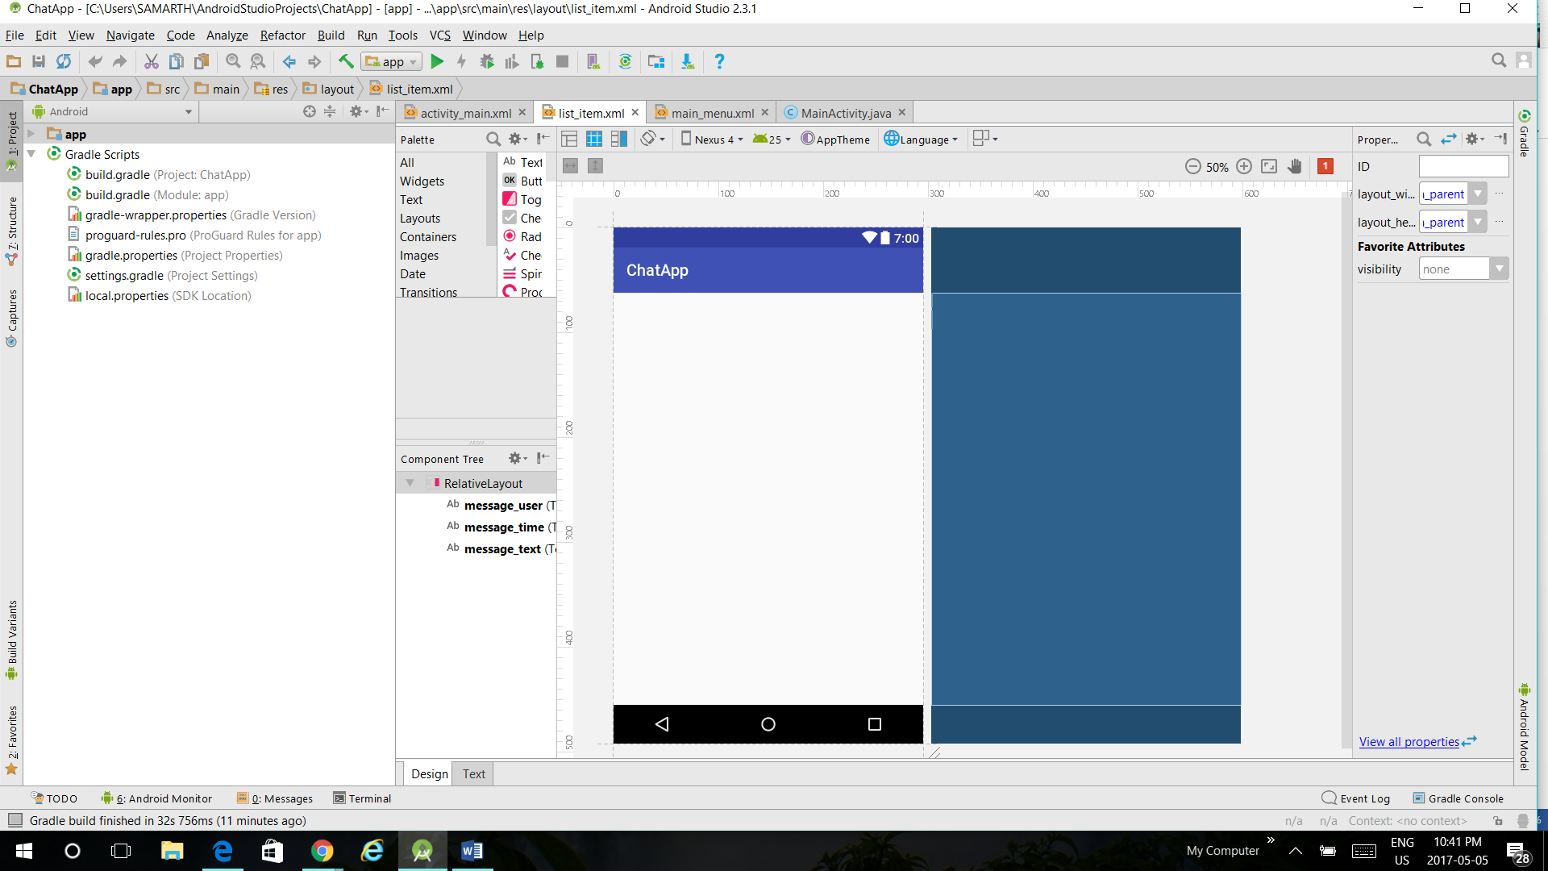

**STAGE 2**

The second stage is where I created “sign-in” and “sign-out” options in my app. Rather than the phone number this app is linked with the user’s email id.

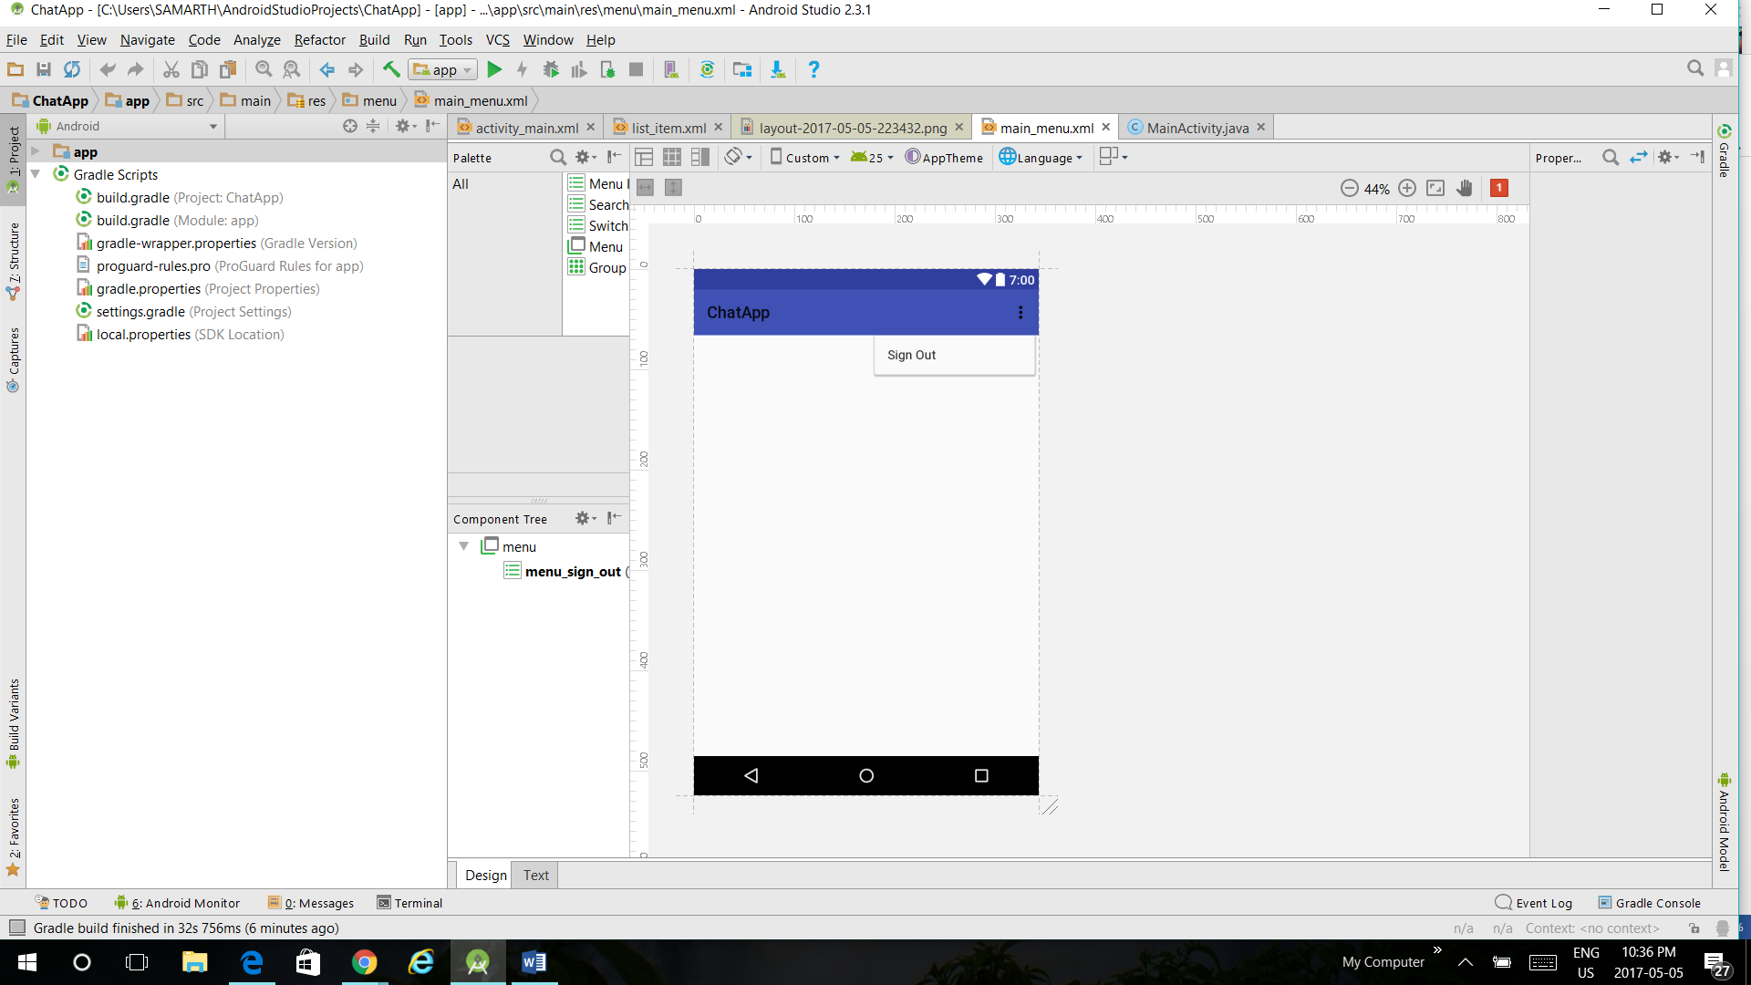

**STAGE 3**

Stage 3 is where the users can send messages with the use of “pink arrow” present at the left bottom of the screen. The Items listed on the screen are the ‘name’ of the contacts and sub-items are their ‘email id’ through which the account is linked to.

